Project Design Phase
Solution Architecture

Date | 30 September 2026
Team ID | SWTID-2026-1437
Project Name | AI WeatherWise API
Maximum Marks | 4 Marks

Solution Architecture:
Solution architecture is a complex process – with many sub-processes – that bridges the gap between business problems and technology solutions. Its goals are to:
- Find the best tech solution to solve existing business problems.
- Describe the structure, characteristics, behavior, and other aspects of the software to project stakeholders.
- Define features, development phases, and solution requirements.
- Provide specifications according to which the solution is defined, managed, and delivered.

Solution Architecture Diagram - AI WeatherWise API:
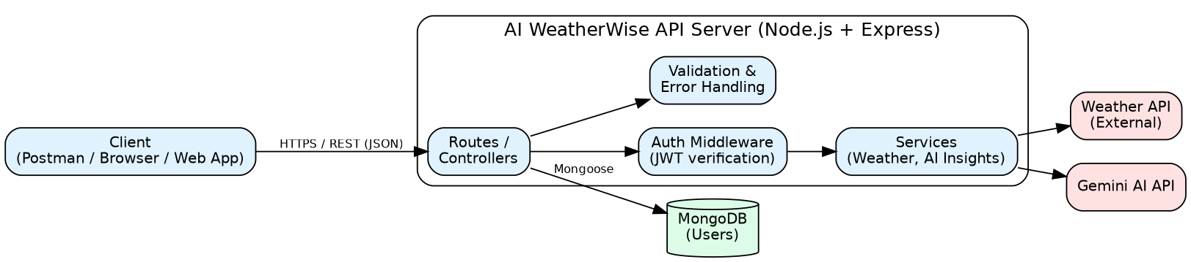
Figure 1: Architecture and data flow of the AI WeatherWise API
The client sends REST requests to the Express server. Requests are validated and, for protected routes, verified by the JWT authentication middleware. Controllers use services to fetch weather data from the external weather API and to generate insights from Gemini AI, while user data is stored in and read from MongoDB.

